Thursday 26th November 2020
RE
LO: To understand the expectations placed on Mary as the mother of Christ.

Write a poem about Mary, outlining her feelings of anticipation and expectation at becoming the Mother of Christ and what this means to us as Christians.

Traditionally, on Sundays and other special days, the pope leads the Angelus from his study window for the pilgrims who gather in St Peter’s Square. Read the prayer below.
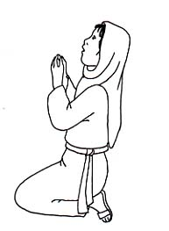
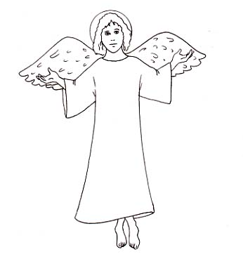
Leader: The angel of the Lord declared unto Mary

Response: And she conceived by the Holy Spirit

All: Hail Mary...

Leader: Behold the handmaid of the Lord

Response: Be it done unto me according to your word

All: Hail Mary...

Leader: And the word was made flesh

Response: And dwelt among us

All: Hail Mary...

Leader: Let us pray

Pour forth, we beseech you, O Lord, your grace into our hearts: that we to whom the Incarnation of Christ your Son was made known by the message of an angel, may, by his Passion and Cross, be brought to the glory of his resurrection. Through the same Christ Our Lord.
Amen.

