Maths
1.07.20 Ratio and Proportion

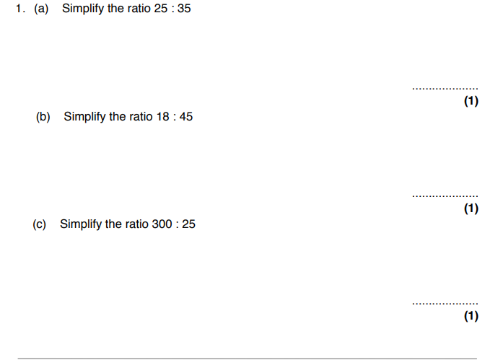

2. Divide £700 in the ratio 5 : 3 : 2

3. Alex and Thomas share 30 sweets. They divide them in the ratio 3:2. How many sweets does Thomas have?
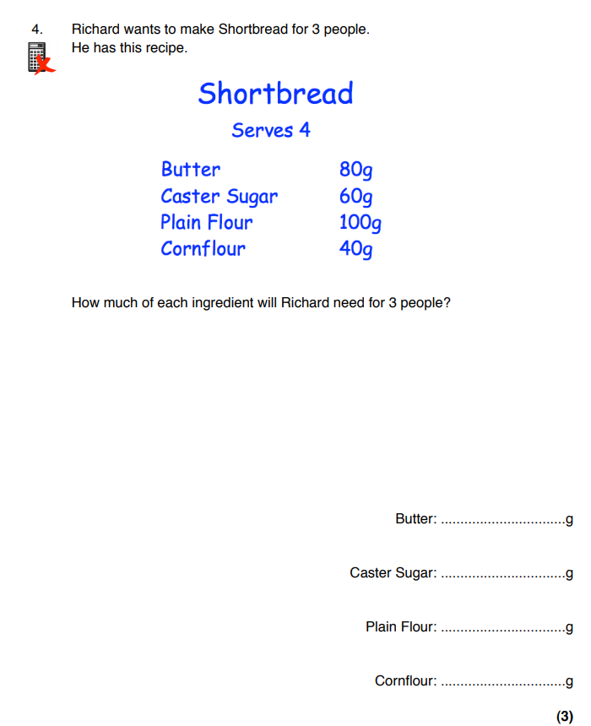

Challenge
