Mama

Mama, you were a marvellous mother,
So gentle, yet so strong.
The many ways you showed you cared
Made me felt I belonged.
You were understanding when I was foolish;
You provided guidance when I asked;
It seemed you could do mostly anything;
You were the master of every task.
You were a reliable source of comfort;
You were my cushion when I fell.
You helped in times of trouble;
You encouraged me whenever I despaired.

You were unpretentious yet compassionate
You never said much about yourself
Whatever I needed to learn
Came from your motivating speeches
And never- ending prayers.
I loved you more than you knew;
You had my total respect.
If I had my choice of mothers,
You'd be the one I'd select!

Your love was a gift to me.
No matter what I did,
Whatever challenge I inflicted,
You would always see me through.

The world around you was massive
Not many knew your worth.
Your personal thoughts were whispered
And only aired to those who listened.

By T. Rodney-McIntosh

Use the poem to answer these questions.

Questions
1.Why is the poem called Mama?
2.Why is the poem written in the past tense?
3. How does the poet feel about Mama? Use evidence from the poem to support your answer.
4. What poetic techniques were used to show the poet’s love for Mama?
5. Which word in the poem tells us that Mama was a modest person?
6. Was Mama aware of the intensity of the poet’s love for her? Explain.

Now, start thinking about your free verse poem.
Who/what will it be about?

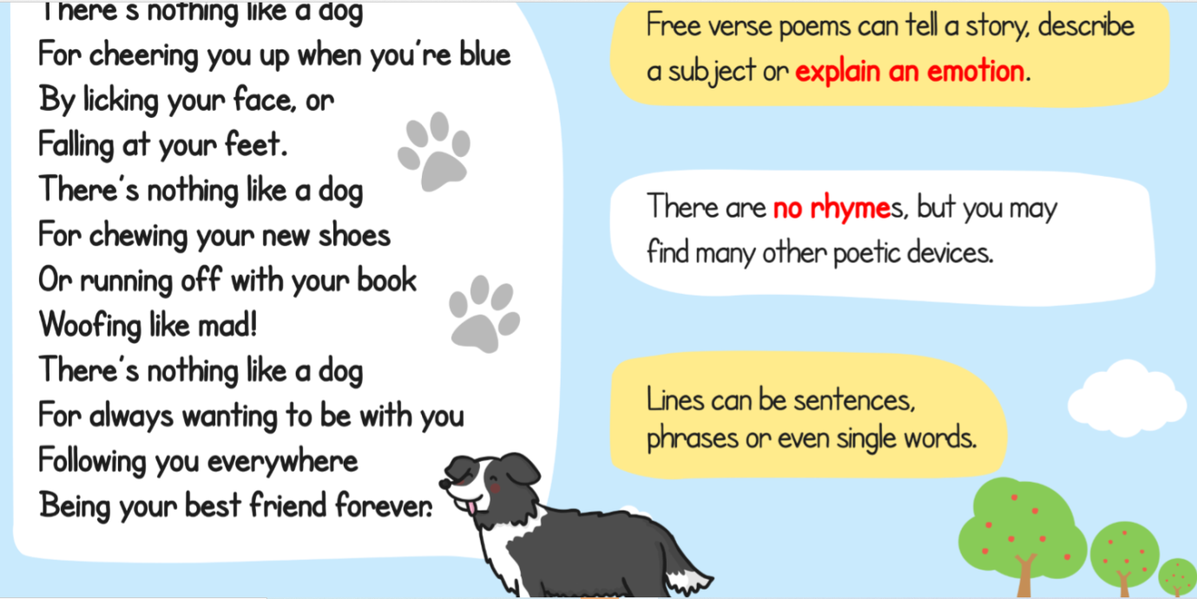

Write your ideas down for tomorrow.

