- Write two sentences with a verb for this picture. One for the caterpillar and one for the tadpole.
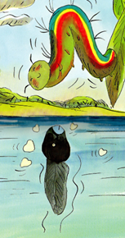

- Draw a picture for these sentences in the box and circle all the verbs you find in the sentences.

“Forgive me,” begged the tadpole.
“I couldn’t help it. I don’t want these legs . . .

- Draw a red love heart over the verbs you find.
She crawled up the willow branch and cried herself to sleep.

- Fill in the missing verb.
One warm moonlit night, she woke up.
The sky had __________________.
The trees had _________________.
Everything had _______________________ .

