Go to
https://www.twinkl.co.uk/
click on Home learning hub
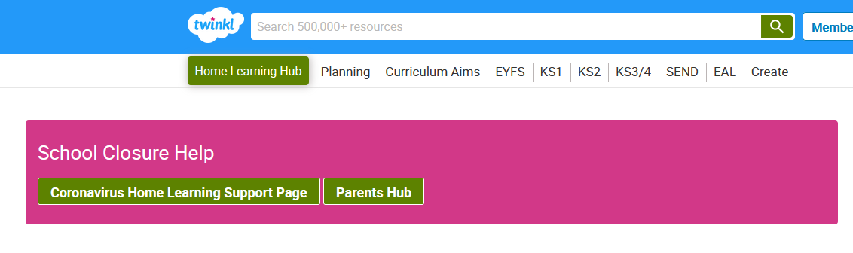
Click on 5-7
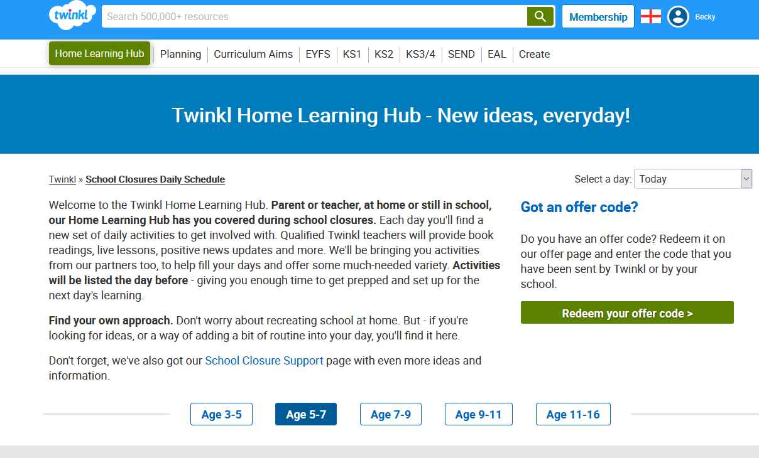
Follow the timetable and activities for the day.

