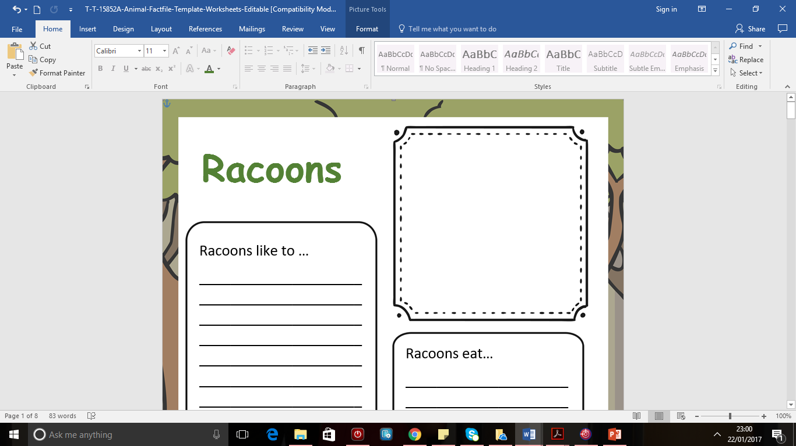

**_______**

Other interesting facts:

__________________________________________________________________________________________________________________________________________________________________________________________________________________________________________________________

Habitat:

_______________________________________________________________________________________________________________________________________

Diet:

_________________________________________________________________________________________________________________________________________________

Description:

________________________________________________________________________________________________________________________________