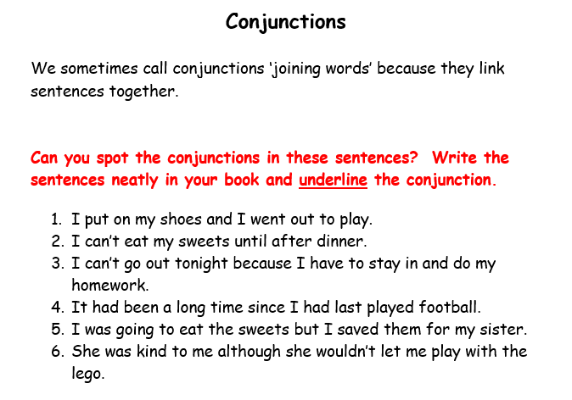
Using the conjunctions and parts of the sentences below create 3 sentences of your own.
